Socialising while social distancing
Spending time with other children is important for your child’s development, but at the moment it is important to follow the rules on social distancing.
While you are spending more time at home together, it will help them if everyone in the home talks with them through the day, responding to them and being led by the things they are interested in.
Ways to stay in touch with others:

Make phone calls to friends and family
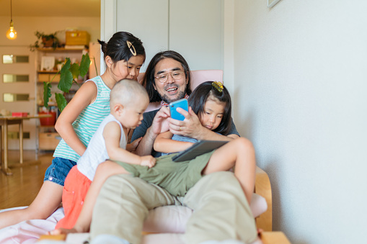

Arrange a video call

Send photos in an email to your nursery or childminder

Draw a picture to send to a friend
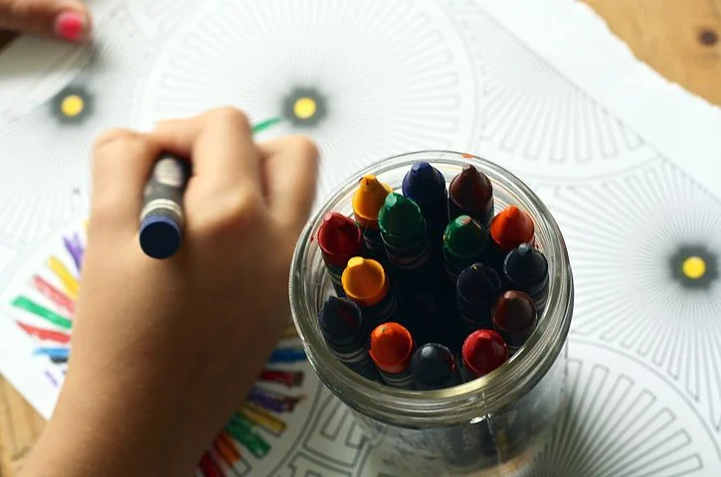

Decorate your windows for your neighbours
