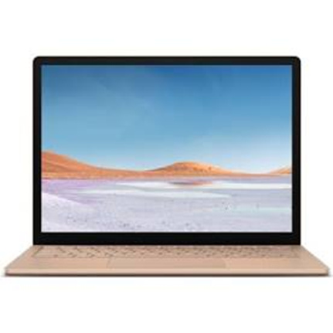

**Online activities for young children**

<https://www.bbc.co.uk/cbeebies>

<https://www.booktrust.org.uk/books-and-reading/have-some-fun/storybooks-and-games/>

<https://2simple.com/purple-mash/>

<https://www.nhs.uk/10-minute-shake-up/shake-ups>

<https://muddyfaces.co.uk/activity/>

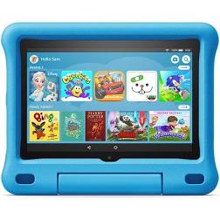

**App suggestions for young children**

