Effective supervisions in your provision

What is in the EYFS Statutory framework?

Staff qualifications, training, support and skills
3.20. Providers must follow their legal responsibilities under the Equality Act 2010 including the fair and equal treatment of practitioners regardless of age, disability, gender reassignment, marriage and civil partnership, pregnancy and maternity, race, religion or belief, sex and sexual orientation.
3.21. The daily experience of children in early years settings and the overall quality of provision depends on all practitioners having appropriate qualifications, training, skills, knowledge, and a clear understanding of their roles and responsibilities. Providers must ensure that all staff receive induction training to help them understand their roles and responsibilities. Induction training must include information about emergency evacuation procedures, safeguarding, child protection, and health and safety issues. Providers must support staff to undertake appropriate training and professional development opportunities to ensure they offer quality learning and development experiences for children that continually improves.
3.22. Providers must put appropriate arrangements in place for the supervision of staff who have contact with children and families. Effective supervision provides support, coaching and training for the practitioner and promotes the interests of children. Supervision should foster a culture of mutual support, teamwork and continuous improvement, which encourages the confidential discussion of sensitive issues.
3.23. Supervision should provide opportunities for staff to:
• discuss any issues – particularly concerning children’s development or wellbeing, including child protection concerns
• identify solutions to address issues as they arise
• receive coaching to improve their personal effectiveness
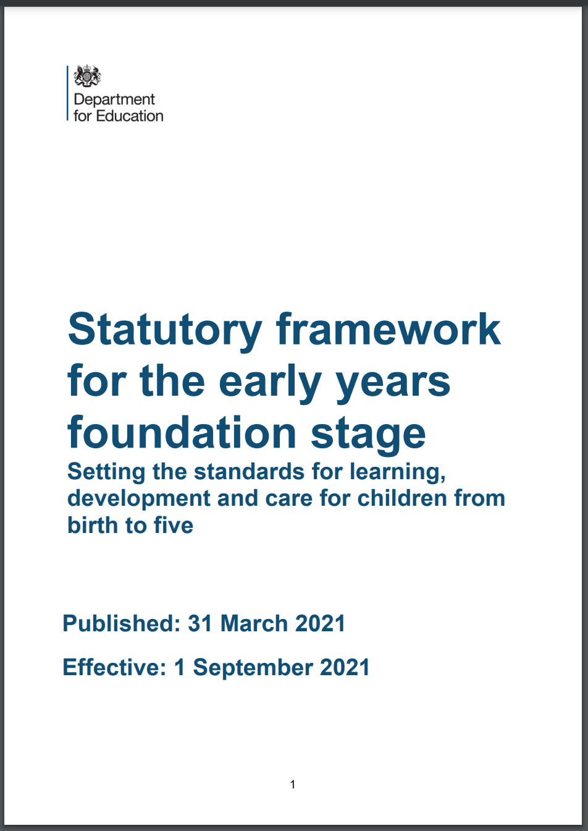
Each member of staff will have appropriate supervision meetings with a member of the management team. These supervision meetings are part of the ongoing supervision and monitoring process that happens in nurseries in a variety of forms (peer to peer observations, daily practice observations managers may make when in rooms with practitioners etc).

You must also remember to make arrangements for supervision meetings for yourself if you are the nursery manager; this could be with the nursery owner, the chair of the management committee or, if appropriate, with a member of the local authority early years team.

Aims of supervision meetings?
Supervision in a nursery is ongoing and takes many forms. Requirements for supervision meetings is to
- provide further opportunities for practitioners to discuss the children’s progress and development,
- their own progress,
- any support or training they may need
- any sensitive issues they may need support with.

Supervision should include opportunities for manager and practitioner to…
● Discuss any safeguarding concerns.
● Support staff members with their development needs.
● Share successes.
● Identify any children who need support.
● Support staff members with their own self-reflection.
● Ensure issues/problems are solved.
● Build trusting relationships that provide a culture of information sharing.

The manager doesn’t always have to be the person who carries out the supervision meetings. It may be that room leaders can do their own room, or the deputy manager could do some.
It is important that your supervisions are structured to provide discussion around staff development and support and any sensitive issues and concerns affecting team members. You should try to ensure that whoever is carrying out the supervision has had appropriate training.

Getting the most from your supervisions
To ensure that your staff are involved in the supervision process you should enable them to have a shared responsibility for supervision meetings. Both parties should be filling out any supervision forms/paperwork prior to the meeting in order to get their thoughts and ideas on paper. This will save time and will ensure a more productive and focused meeting.

Opportunities for issues to be discussed include…
● The staff member’s relationship with key children and their parents.
● What has the staff member enjoyed most/least since the last supervision meeting? What has had the most impact for their key children?
● Are there any areas of work they need support with?
● Date of next meeting and actions to be completed before the next meeting.
Supervision meetings are likely to identify development needs which as manager you can then plan to address through inhouse or external training.

